PERSONAL DETAILS
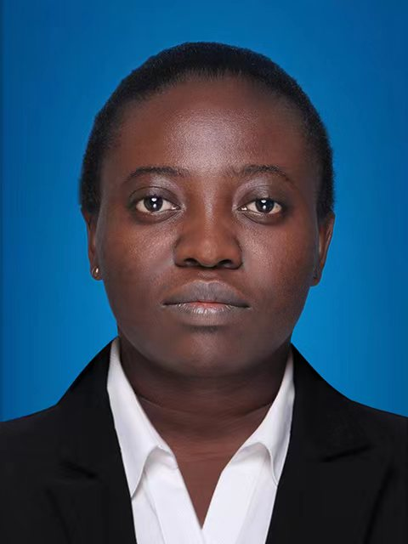  Paste your photo | Full Name | Millicent Appiah
 | Gender | Female
 | Designation | Dr.
 | Department | Material Science & Engineering
 | Institution/Organization | Wuhan University of Technology/Guangdong Technion Israel Institute of Technology
 | Qualification | PhD/Post-Doctoral Studies
 | Area of Specialization | Dielectric ceramic materials for Multilayer Ceramic Capacitors (MLCCs) and microwave dielectric ceramics
 | Sub Division | Temperature stable lead-free dielectric ceramics for MLCCs and high quality-factor microwave dielectrics for millimeter wave applications.
 | DOB | 28 - 04 - 1989
 | DOJ
 | Total Experience | 7years
 | Mobile Number | +86 15549453573
 | Email | millycey@yahoo.com, millycey1@gmail.com, millicent.appiah@gtiit.edu.cn
About your Education, Experience and Academic achievements (200 words)

EDUCATION

- 2021 to Date: Post-Doctoral Fellow in MSE (Guangdong Technion-Israel Institute of Technology)
- 2017 to 2021: PhD in Materials Science & Engineering (Wuhan University of Technology)

- 2014 to 2017: MSc in Materials Science & Engineering (Wuhan University of Technology - China)

- 2009 to 2013: BSc in Materials Engineering (Kwame Nkrumah University of Science & Technology - Ghana)

EXPERIENCE

Currently a Post-doctoral fellow student in GTIIT, now focusing on reviewing and tuning high-quality factor (Qf) microwave dielectric materials for millimeter-wave applications, personal desire to add-up to the advancement of material processing alternatives to fine-tune the structure-property-relationship for expected functional applications. In addition, as a research guide for undergraduates’ projects. Much more, having a background experience of 7years at the State Key Laboratory of Advanced Technology for Materials Synthesis and Processing, Wuhan University of Technology (China) under the supervision of Professor Hua Hao as MSc and PhD student. Mainly concentrating on lead-free dielectric ceramic fabrications for multilayer ceramic capacitors. Accordingly, unveiling dielectric properties with harmonized temperature stability and energy storage applications. Lastly, growing experience in revising thesis/manuscripts.

ACADEMICS ACHIEVEMENTS

- About 10 publications as indicated in the curriculum vitae, with more than 140 citations and 2000 reads, one project presented at ISAF virtual conference, May 2021).

RESEARCH, INNOVATIONS AND EXTENSION
Question | Nos. | Question | Nos.
No. of Research Project Completed and On Going | 3 Completed/  4 Ongoing | Citation index in Scopus/ Web of Science or PubMed/ Indian Citation Index | 149
No. of Consultancy and Industries Sponsored Projects |  | No. of Books Published with ISBN  (Text, Reference, Chapters and Conference Proceedings)
Total cost of the all Projects in USD/INR |  | No. of Patent Published and Under Process
No. of Journals Published in SCI and SCIE index | 10 | No. of Editorial Appointments in Journals/ Conferences (Editor, Reviewer and Member)
No. of Journals Published in Scopus, Web of Science and PubMed index | 10 | No of Countries Visited for research activities
No. of Journals Published in Other index |  | No. of Research scholar Graduated
No. of Conference Presentation | 1 | No. of Research scholar On Going
Cumulative impact factor of the last 3 years | 25 | No. Invited Speaker/ Resource person
H-index: Bibliometrics of the publications based on Scopus/ Web of Science. | 5 | No. of Research Conference/workshop Organized
Total number of Collaborative activities for research: (Joint publication/Project) |  | Total number of awards and recognition received
Number of functional MoUs with other universities/ industries/ corporate. |  | No. of Member of Professional Bodies:
Areas of Research | Lead-Free temperature stable and microwave dielectric ceramics.
About your contribution towards the Research & Development, Innovations, and Extension Activities (200 words)

The principal contribution is sustaining an underlying knowledge in the chemistry dynamics of dielectric materials (binary or ternary systems), the effective compositional modifications (B-site substitution) and diverse material fabrication/synthesis. Thus, yielding good dielectric temperature-stable potentials aligned with the experimental interpretations of core−shell-structured morphology, fine-tuning grain-sizes and robust density developments. Therefore, relating structure−property relationship to optimize dielectric properties that meets the standards for electronic applications. Unique innovations are established through effective material characterizations and analyses, connecting results and discussions from the raw materials, phase structures, microstructural progresses, calcination/sintering temperatures (thermal behaviors) etc., adding-up to the informative advancement of dielectric researches and materials science. The summary of research contributions are clearly evident by the various parameters considered in the analyses of published works. Growing experience in revising thesis/manuscripts as extension activities

PERSONAL/ RESEARCH PROOFS, CATEGORY OF AWARD AND DECLARATION

Google scholar link  (Publication Proof) | https://scholar.google.com/citations?hl=en&user=oezRr14AAAAJ
Scopus link  (Publication Proof) | https://www.scopus.com/authid/detail.uri?authorId=56703087400
Linkedin link  (Publication Proof) | https://www.linkedin.cn/incareer/in/millicent-appiah-475560b0/
Researchgate link  (Publication Proof) | https://www.researchgate.net/profile/Millicent-Appiah-2
Institute ID Link/Upload/Number
(Working Proof)
Certificate Links/Upload/Number
(Education Proof of Last degree)
Passport/ Govt. ID Links/Upload/ Number (Age Proof)
Personal website link
Tick the Suitable award category | - Distinguished Scientist Award  ☑ Young Scientist Award  - Life time achievement Award  - Outstanding scientist award  - Women Research Award  - Best Researcher Award  - Best Innovation Award | - Best Faculty Award  - Best Research Scholar Award  - Excellence in Innovation  - Excellence in Research  - Excellence Award (Any Scientific field)  - Best Research /Innovation Extension activity.
Self Declaration
I authenticate that to the best of my knowledge, the information given in this form is correct and complete. At any time I am found to have concealed any material information, my application shall be liable to be summarily terminated without notice. I have read the terms and conditions and other policies of the International Research Awards and agree to stand the same. I agree to Pencis to process the data submitted in this application form, or any other data that the Foundation may obtain from me for any purposes connected with Pencis for any other legitimate reason. The filled applications along with duly completed curriculum vitae, Pass port size photograph, Scan copy of the degree Certificate, Scan copy of the Working ID and related documents should be Upload in website/ sent via email to : contact@pencis.com

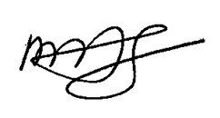
Date: 2022/08/07 Place : Shantou-Guangdong (China) Scanned Signature of Applicant

Office Use only

Decision | Reason | Signature of authorities | Date
Selected/Rejected

