PERSONAL DETAILS
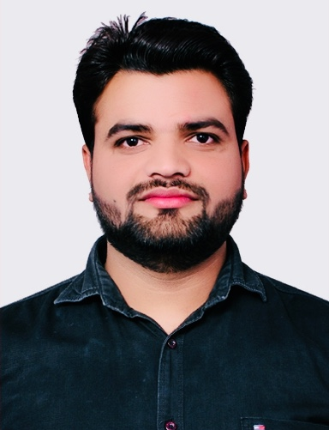 | Full Name | Himanshu Raghav
 | Gender | Male
 | Designation | Senior research fellow
 | Department | Catalytic depolymerisation Area  Upstream & Wax Rheology Division
 | Institution/Organization | CSIR-Indian Institute of Petroleum, Dehradun India
 | Qualification | M.Sc
 | Area of Specialization | Heterogeneous Catalysis
 | Sub Division | Catalytic depolymerisation Area
 | DOB | 16 Sep 1992
 | DOJ | 14 Jan 2019
 | Total Experience | 3.5 Years
 | Mobile Number | 9997449772
 | Email | himanshuraghav58@gmail.com
About your Education, Experience and Academic achievements (200 words)

I completed my B.Sc. from M.J.P. Rohilkhand University in 2011. Subsequently, I obtained an M.Sc. degree (Organic Chemistry) from Chaudhary Charan Singh University Meerut in 2014. I qualified for UGC NET JRF in Dec 2017, Jun 2018 and Dec 2018 and GATE in 2018 and 2019. I am currently working as a PhD student at the Indian Institute of petroleum, Dehradun since 2019 under the supervision of Dr Bipul Sarkar. My current research work is “Synthesis of multifunctional metal oxide catalyst(s) for alternative production of light olefins”. My hobbies are sketch arts, writing and playing cricket.

RESEARCH, INNOVATIONS AND EXTENSION
Question | Nos. | Question | Nos.
No. of Research Project Completed and On Going | 6 | Citation index in Scopus/ Web of Science or PubMed/ Indian Citation Index | -
No. of Consultancy and Industries Sponsored Projects | 1 | No. of Books Published with ISBN  (Text, Reference, Chapters and Conference Proceedings) | -
Total cost of the all Projects in USD/INR | - | No. of Patent Published and Under Process | 1
No. of Journals Published in SCI and SCIE index | 2 | No. of Editorial Appointments in Journals/ Conferences (Editor, Reviewer and Member) | -
No. of Journals Published in Scopus, Web of Science and PubMed index | 2 | No of Countries Visited for research activities | -
No. of Journals Published in Other index | 1 | No. of Research scholar Graduated | -
No. of Conference Presentation | 1 | No. of Research scholar On Going | -
Cumulative impact factor of the last 3 years | - | No. Invited Speaker/ Resource person | -
H-index: Bibliometrics of the publications based on Scopus/ Web of Science. | - | No. of Research Conference/workshop Organized | -
Total number of Collaborative activities for research: (Joint publication/Project) | - | Total number of awards and recognition received | -
Number of functional MoUs with other universities/ industries/ corporate. | - | No. of Member of Professional Bodies: | -
Areas of Research | Synthesis of multifunctional metal oxide catalyst(s) for alternative production of light olefins
About your contribution towards the Research & Development, Innovations, and Extension Activities (200 words)

PERSONAL/ RESEARCH PROOFS, CATEGORY OF AWARD AND DECLARATION

Google scholar link  (Publication Proof) | https://scholar.google.com/citations?user=0-Mvp5wAAAAJ&hl=en&authuser=2
Scopus link
(Publication Proof)
LinkedIn link  (Publication Proof) | https://www.linkedin.com/feed/
ResearchGate link  (Publication Proof) | https://www.researchgate.net/profile/Himanshu-Raghav
Institute ID Link/Upload/Number  (Working Proof) | https://www.iip.res.in/
Certificate Links/Upload/Number
(Education Proof of Last degree)
Passport/ Govt. ID Links/Upload/ Number (Age Proof)
Personal website link | https://www.suscarelab.com/
Tick the Suitable award category | - Best Paper Award  - Best Researcher Award  - Most Cited Article Award  - Most Reader's Article Award  - Best Review Article Award  - Most Cited Author Award | - Best Research Article Award  - Most Tweeted Article Award  - Fast Cited Article Award  - Most Commended Article Award  - Most Shared Article Award
Self-Declaration
I authenticate that to the best of my knowledge, the information given in this form is correct and complete. At any time, I am found to have concealed any material information, my application shall be liable to be summarily terminated without notice. I have read the terms and conditions and other policies of the International Research Awards and agree to stand the same. I agree to Sciencefather to process the data submitted in this application form, or any other data that the Foundation may obtain from me for any purposes connected with Sciencefather for any other legitimate reason. The filled applications along with duly completed curriculum vitae, Pass port size photograph, Scan copy of the degree Certificate, Scan copy of the Working ID and related documents should be Upload in website/ sent via email to: contact@sciencefather.com
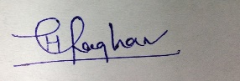

Date : Place : Scanned Signature of Applicant

Office Use only

Decision | Reason | Signature of authorities | Date
Selected/Rejected

