PERSONAL DETAILS
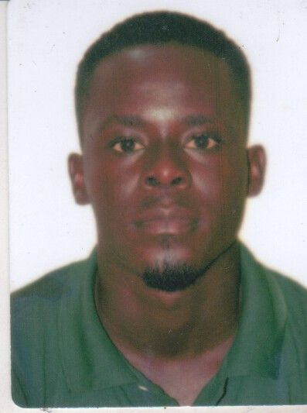Paste your photo | Full Name | Evans Kulu
 | Gender | Male
 | Designation | Assistant Lecturer
 | Department | Industrial Mathematics
 | Institution/Organization | C.K. Tedam University of Technology and Applied Sciences
 | Qualification | MPhil Economics
 | Area of Specialization | Macroeconomic Studies
 | Sub Division | Development Economics, Finance and Public Sector Economics
 | DOB | 21/09/1990
 | DOJ
 | Total Experience
 | Mobile Number | +233547465320
 | Email | ekulu@cktutas.edu.gh
About your Education, Experience and Academic achievements (200 words)

I have had all my stages of education in Ghana. I had both basic and senior high school education in Nzemaman Complex School and St. John’s School respectively. In the year 2011, I enrolled in the University of Cape Coast to read Bachelor of Arts in Economics and graduated in 2015. In the same University, I read Master of Philosophy in Economics from 2016 to 2018. I won the Samuel and Emelia Brew-Butler-SGS/GRASAG, UCC Research Grant and became the first Economics student to successfully complete the thesis. In the year 2019, I also enrolled in the same University to read Doctor of Philosophy in Economics. Currently, I am through with the course work and finalizing the research work. The topic under study is Government Domestic Arrears, Private Investment and Financial Stability Gap in sub-Saharan Africa.

RESEARCH, INNOVATIONS AND EXTENSION
Question | Nos. | Question | Nos.
No. of Research Project Completed and On Going | 16 | Citation index in Scopus/ Web of Science or PubMed/ Indian Citation Index | 9
No. of Consultancy and Industries Sponsored Projects | 0 | No. of Books Published with ISBN  (Text, Reference, Chapters and Conference Proceedings) | 0
Total cost of the all Projects in USD/INR | 0 | No. of Patent Published and Under Process | 0
No. of Journals Published in SCI and SCIE index | 6 | No. of Editorial Appointments in Journals/ Conferences (Editor, Reviewer and Member) | 6
No. of Journals Published in Scopus, Web of Science and PubMed index | 5 | No of Countries Visited for research activities | 0
No. of Journals Published in Other index | 2 | No. of Research scholar Graduated | 0
No. of Conference Presentation | 0 | No. of Research scholar On Going | 2
Cumulative impact factor of the last 3 years | 11.746 | No. Invited Speaker/ Resource person | 1
H-index: Bibliometrics of the publications based on Scopus/ Web of Science. |  | No. of Research Conference/workshop Organized | 0
Total number of Collaborative activities for research: (Joint publication/Project) | 6 | Total number of awards and recognition received | 1
Number of functional MoUs with other universities/ industries/ corporate. | 0 | No. of Member of Professional Bodies: | 4
Areas of Research
About your contribution towards the Research & Development, Innovations, and Extension Activities (200 words)

My contribution towards research started after my MPhil degree in the year 2019. As a young and new researcher, I have assisted senior faculty members in conducting different research works for instance, the Mid-Term Evaluation of the Cocoa Rehabilitation and Intensification Programme Phase II (CORIP II) in Ghana, the Impact of Mobile Money on Small Holder Farms etc. after completing my master’s degree, I was also employed as a research assistant after my master’s degree where I assisted in several research activities such designing research instruments, collecting data, analyzing data and writing reports.
Recently, I collaborated with colleagues to research on mobile money and its effect on the banking sector performance in Ghana. This study was influenced by the rising patronage of mobile money and the recent banking sector challenges in Ghana. Also, given the increasing domestic debt and arrears in sub-Saharan Africa as well as the relevance of the financial sector, I have led in publishing two related works; 1. Government Domestic Debt Arrears and Private Investment in SSA, 2. Inefficiencies and Gaps in Financial Stability in SSA. I have as well collaborated in publishing a study on Renewable Energy Production and Employment: Comparative Analysis on European and Asian Countries.

PERSONAL/ RESEARCH PROOFS, CATEGORY OF AWARD AND DECLARATION

Google scholar link  (Publication Proof) | https://scholar.google.com/citations?user=wAcylswAAAAJ&hl=en&oi=ao
Scopus link
(Publication Proof)
LinkedIn link
(Publication Proof)
ResearchGate link
(Publication Proof)
Institute ID Link/Upload/Number
(Working Proof)
Certificate Links/Upload/Number
(Education Proof of Last degree)
Passport/ Govt. ID Links/Upload/ Number (Age Proof)
Personal website link
Tick the Suitable award category | - Best Paper Award  √Best Researcher Award  - Most Cited Article Award  - Most Reader's Article Award  - Best Review Article Award  - Most Cited Author Award | - Best Research Article Award  - Most Tweeted Article Award  - Fast Cited Article Award  - Most Commended Article Award  - Most Shared Article Award
Self-Declaration
I authenticate that to the best of my knowledge, the information given in this form is correct and complete. At any time, I am found to have concealed any material information, my application shall be liable to be summarily terminated without notice. I have read the terms and conditions and other policies of the International Research Awards and agree to stand the same. I agree to Sciencefather to process the data submitted in this application form, or any other data that the Foundation may obtain from me for any purposes connected with Sciencefather for any other legitimate reason. The filled applications along with duly completed curriculum vitae, Pass port size photograph, Scan copy of the degree Certificate, Scan copy of the Working ID and related documents should be Upload in website/ sent via email to: contact@sciencefather.com

Date :23/11/2022 Place : Accra Scanned Signature of Applicant

Office Use only

Decision | Reason | Signature of authorities | Date
Selected/Rejected

