Curriculum Vitae
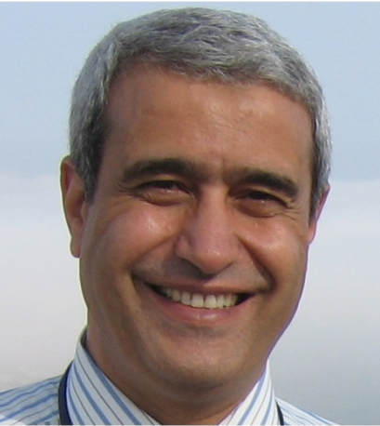
PERSONAL:
Name : Zein El-Abidin kamel Heiba
Abdel Aziz
Nationality : Egyptian

Current Job : Professor of physics

Scopus ID : 6602591867

h-index: : 23

Address : Present:

Ain Shams University, Faculty of Science, Physics Department.

Cairo, Eygpt.

Mobil : 00201006345336

E-Mail Zein_kh@yahoo.com
B.Sc.: Physics (excellent/honors), May 1976, Ain Shams University, Faculty of Science, Cairo, Egypt.

M.Sc.: Physics, Electronics, March 1981, Ain Shams University Faculty of Science, Cairo, Egypt. “Study of oscillatory systems applying multivalued non-linear devices”.

Ph.D : Physics, Solid state, X-ray diffraction and crystal structure, January 1987, Ain Shams University, Cairo, Egypt, in cooperation with Bonn University through 'channel system'. “Low temperature X-ray diffraction analysis of the lattice distortion and the structure of crystals in connection with magnetic ordering”.

ACADEMIC POSITIONS HELD:
Dec.03 – Now :- Professor of solid state physics; crystal structure
Physics Dept., Faculty of Science, Ain Shams Univ.,
Cairo, Eygpt.
- Director of Crystal Structure and X-ray Diffraction Unit,
Scientific Studies and Consultations center
Dec.03 – Sep. 09 - Chairman of solid-state group
Sep.09 – Sep. 15 : Professor of solid state; Physics Dept., Faculty of Science,
Taif Univ., Saudi Arabia.
Jun. 01 – Dec.02 : On leave, research fellowship, Florida State Univ.,
NHMFL, USA.
Jun.95 – Dec.03 : Associate Professor of crystallography, Physics Dept., Faculty
of Science, Ain Shams Univ., Cairo, Egypt.

Feb. 87 – Oct. 95 : Lecturer, Physics Dept., Faculty of Science, Ain Shams
University.

Dec. 82 – Aug 85 : Ph.D. Student, Mineralogisches Institut der Universitat
Bonn, Germany.
Oct. 76 – Dec. 82 : Lecturer Assistant, Physics Dept., Faculty of Science,
Ain Shams Univ., Cairo, Egypt

Experience and administrative positions
- Director of Crystal Structure and X-ray Diffraction Unit, Scientific Studies and Consultations center, faculty of science.
- Director of Graduate Studies central control
- Treasurer and Member of the administrative board of the Egyptian Society of crystallography
- Chairman of the administrative board of Ain Shams University Housing Association

Membership of Professional and scientific associations
- Membership of the International Union of Crystallography IUCr.
- Membership of the Egyptian national committee of Synchrotron Light Application
- Membership of the Egyptian society of crystallography and applications. (Administrative board)
- Membership of the Egyptian national committee of crystallography.
- Membership of the Egyptian materials research Society.
- Membership of Ain Shams University Housing Association.

Research Interests

- Electrode materials for Li-ion Batteries and supercapacitors
- Rare earth doped oxides; Multiferroics.
- Magnetic materials, Crystal structure and Microstructure (size/strain) analysis
- Structural related properties
PUBLICATIONS Peer reviewed papers:
Scholar Google 186 Articles
https://scholar.google.com/citations?authuser=0&user=UNftW_IAAAAJ

