PERSONAL DETAILS
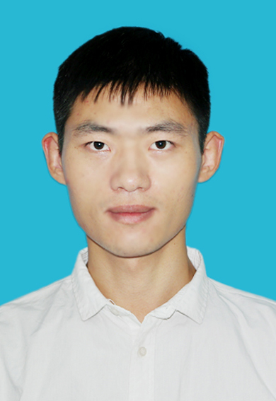 | Full Name | Henggao Xiang
 | Gender | Male
 | Designation | Professor
 | Department | Nanjing University of Science and Technology
 | Institution/Organization | School of materials science and Engineering
 | Qualification | Doctor
 | Area of Specialization | Engineering
 | Sub Division | Mechanics of Materials
 | DOB
 | DOJ
 | Total Experience
 | Mobile Number | +86 18851893795
 | Email
About your Education, Experience and Academic achievements (200 words)
1. Education:
2019.09—2021.12 Nanjing University of Aeronautics and Astronautics Doctor
2015.09—2018.06 Chongqing University Master
2011.09—2015.06 Nanjing Agricultural University Bachelor
2. Experience
2022.01 up to now Nanjing University of Science and Technology Academic Title: Professor
3. Academic achievements
Xiang has published 24 papers in recent years, of which the first/corresponding author is at Acta Materialia, International Journal of Plasticity and other authoritative journals published 13 papers, with a total of 430 citations. These papers were cited positively for many times by well-known scholars, such as Bai Yilong, academician of Chinese Academy of Sciences; Professor Liu Sheng, academician of IEEE; I. J. Beyerlein, Editor of Acta Materialia; Mingwang Fu, Editor of International Journal of Plasticity; and Guozheng Kang, editor in chief of International Journal of Fatigue.

RESEARCH, INNOVATIONS AND EXTENSION
Question | Nos. | Question | Nos.
No. of Research Project Completed and On Going | 5 | Citation index in Scopus/ Web of Science or PubMed/ Indian Citation Index | 430
No. of Consultancy and Industries Sponsored Projects | 5 | No. of Books Published with ISBN  (Text, Reference, Chapters and Conference Proceedings) | 0
Total cost of the all Projects in USD/INR | 59200 USD | No. of Patent Published and Under Process | 3
No. of Journals Published in SCI and SCIE index | 23 | No. of Editorial Appointments in Journals/ Conferences (Editor, Reviewer and Member) | 2
No. of Journals Published in Scopus, Web of Science and PubMed index | 24 | No of Countries Visited for research activities | 1
No. of Journals Published in Other index | 1 | No. of Research scholar Graduated | 2
No. of Conference Presentation | 1 | No. of Research scholar On Going | 2
Cumulative impact factor of the last 3 years | 36.852 | No. Invited Speaker/ Resource person | 1
H-index: Bibliometrics of the publications based on Scopus/ Web of Science. | 13 | No. of Research Conference/workshop Organized | 1
Total number of Collaborative activities for research: (Joint publication/Project) | 8 | Total number of awards and recognition received | 2
Number of functional MoUs with other universities/ industries/ corporate. | 1 | No. of Member of Professional Bodies: | 1
Areas of Research | Engeering
About your contribution towards the Research & Development, Innovations, and Extension Activities (200 words)

(1) Research on mechanical behavior of TiAl single crystal: The Nb-Al-Ti ternary potential suitable for high temperature applications is developed, and the deformation evolution law of TiAl single crystal at high temperature is successfully predicted by using this potential function. A new mechanism of room temperature strengthening and toughening of TiAl single crystal is proposed, that is, the synergistic effect of twin grain boundary and phase boundary can synchronously improve the room temperature strength and ductility of TiAl single crystal.

(2) Research on failure mechanism of structural materials: The "nested" mechanism of dislocation ring formation in transition metal nitrides is proposed for the first time, that is, the screw dislocation parts of two adjacent shear rings can cross slip and annihilate, so as to merge into a dislocation ring. The results are consistent with the experiment. It is found that this new mechanism is applicable to almost all structural materials, from metals to ceramics.

PERSONAL/ RESEARCH PROOFS, CATEGORY OF AWARD AND DECLARATION

Google scholar link  (Publication Proof) | https://xs2.dailyheadlines.cc/citations?user=_MibMJYAAAAJ&hl=zh-CN&oi=ao
Scopus link  (Publication Proof) | https://www.scopus.com/authid/detail.uri?authorId=57192811293
Linkedin link
(Publication Proof)
Researchgate link  (Publication Proof) | https://www.researchgate.net/profile/Henggao-Xiang
Institute ID Link/Upload/Number  (Working Proof) | https://amim.njust.edu.cn/67/c0/c8991a288704/page.htm
Certificate Links/Upload/Number  (Education Proof of Last degree) | 1028722022000009
Passport/ Govt. ID Links/Upload/ Number (Age Proof) | 320721199110281612
Personal website link | https://amim.njust.edu.cn/67/c0/c8991a288704/page.htm
Tick the Suitable award category | - Distinguished Scientist Award  - Young Scientist Award  - Life time achievement Award  - Outstanding scientist award  - Women Research Award  √Best Researcher Award  - Best Innovation Award | - Best Faculty Award  - Best Research Scholar Award  - Excellence in Innovation  - Excellence in Research  - Excellence Award (Any Scientific field)  - Best Research /Innovation Extension activity.
Self Declaration
I authenticate that to the best of my knowledge, the information given in this form is correct and complete. At any time I am found to have concealed any material information, my application shall be liable to be summarily terminated without notice. I have read the terms and conditions and other policies of the International Research Awards and agree to stand the same. I agree to Pencis to process the data submitted in this application form, or any other data that the Foundation may obtain from me for any purposes connected with Pencis for any other legitimate reason. The filled applications along with duly completed curriculum vitae, Pass port size photograph, Scan copy of the degree Certificate, Scan copy of the Working ID and related documents should be Upload in website/ sent via email to : contact@pencis.com

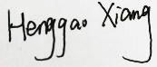
Date :2022/7/27 Place : Nanjing Scanned Signature of Applicant:

Office Use only

Decision | Reason | Signature of authorities | Date
Selected/Rejected

