Curriculum Vitae
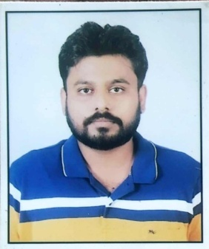
Dr. Nripendra Singh
B.V.Sc & A.H, P.G.D.A.W
M.V.Sc ( Veterinary Anatomy & Histology )
Reg No. UPVC- 7327, VCI- 10798
Ex Veterinary Doctor at Sanjay Gandhi Animal Care Center,
Raja Garden,New Delhi 110027

CONTACT DETAILS:
Permanent Address. |  | 128A/5L, Preetam Nagar, Sulem Sarai Prayagraj (U.P.) Pin-211011
Contact No. |  | +91 9450515614
Email. |  | nripendra.singh838@gmail.com
ACADEMICS DETAIL:
Exam passed | Year | Board/University | Division
High School | 2012 | CBSE Board | 1st
Intermediate | 2014 | U.P Board | 1st
B.V.Sc. & A.H. | 2020 | A.N.D.U.A.&T., Kumarganj, Ayodhya | 1st
P.G.D.A.W. | 2021 | I.G.N.O.U New Delhi | 1^{s}
M.V.Sc. | 2022 | A.N.D.U.A.&T., Kumarganj, Ayodhya | 1st

RESEARCH WORK:
My research work on “Gross Morphological & Histological Studies on Mammary Gland of Barbari Goat”
EXTRA ACTIVITY:
- Published 30 article in various National ,International Magzine & News papers.
- Dr. V. Kurien Award of Excellence 2021.
- Awadhesh Kumar Singh Memorial Award 2021.
- Louis Pasteur Award of Excellence 2021.

PROFESSIONAL INTREST
1. Keen Intrest in Clinical subjects & Practices and can responsively handle most of the Clinical Cases.
MEMBERSHIP
Register member of Uttar Pradesh State Veterinary Council
Register member of Veterinary Council of India
Register member of Indian Association of Veterinary Anatomist
Registered member of PASHUDHAN PRAHAREE
PERSONAL PROFILE
Name |  | Dr. Nripendra Singh
Father’s Name |  | Mr. Narendra Singh
Mother’s Name |  | Mrs. Santoshi Singh
Date of Birth |  | 15 March, 1997
Sex |  | Male
Marital Status |  | Un-married
Religion |  | Hinduism
Nationality |  | Indian

DECLERATION
I hereby declare that all the information provided above is true to the best of my knowledge.
Dr.Nripendra Singh

