PERSONAL DETAILS
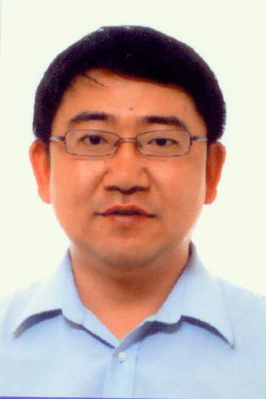  Paste your photo | Full Name | Xue Qin
 | Gender | male
 | Designation | professor
 | Department | chemistry
 | Institution/Organization | Tianjin university
 | Qualification | Professor
 | Area of Specialization | Electrochemisty
 | Sub Division
 | DOB | 1973-02-18
 | DOJ | 2005-1-1
 | Total Experience | 17 years
 | Mobile Number | 86-13920603736
 | Email | qinxue@tju.edu.cn
About your Education, Experience and Academic achievements (200 words)
Education experience:
1998.09 – 2001.06, Ph.D, Institute of new energy materials chemistry, Nankai University
1995.09 – 1998.03, Master, School of Chemical Engineering and Technology, Tianjin University
1991.09 – 1995.06, Bachelor, Department of Applied Chemistry, Tianjin University

Work experience:
2014.07 – Current, Professor, Department of chemistry, School of science, Tianjin University
2005.01 – 2014.06, Associate professor, Department of chemistry, School of science, Tianjin University
2003.01 – 2004.12, Postdoctor, Department of chemistry, Technikon Witwatersrand(University of Johannesburg) , South Africa
2001,09 – 2002.11 Research Fellow, Department of physics, National University of Singapore, Singapore

RESEARCH, INNOVATIONS AND EXTENSION
Question | Nos. | Question | Nos.
No. of Research Project Completed and On Going | 5 | Citation index in Scopus/ Web of Science or PubMed/ Indian Citation Index | 2396
No. of Consultancy and Industries Sponsored Projects | 3 | No. of Books Published with ISBN  (Text, Reference, Chapters and Conference Proceedings) | 4
Total cost of the all Projects in USD/INR | 100,000 | No. of Patent Published and Under Process | 3
No. of Journals Published in SCI and SCIE index | 44 | No. of Editorial Appointments in Journals/ Conferences (Editor, Reviewer and Member) | 0
No. of Journals Published in Scopus, Web of Science and PubMed index | 49 | No of Countries Visited for research activities | 2
No. of Journals Published in Other index | 0 | No. of Research scholar Graduated | 12
No. of Conference Presentation | 4 | No. of Research scholar On Going | 4
Cumulative impact factor of the last 3 years | 50.1 | No. Invited Speaker/ Resource person | 2
H-index: Bibliometrics of the publications based on Scopus/ Web of Science. | 19 | No. of Research Conference/workshop Organized | 0
Total number of Collaborative activities for research: (Joint publication/Project) | 2 | Total number of awards and recognition received | 1
Number of functional MoUs with other universities/ industries/ corporate. | 1 | No. of Member of Professional Bodies: | 80
Areas of Research | Li-ion battery
About your contribution towards the Research & Development, Innovations, and Extension Activities (200 words)

In the past 17 years, my main research fields include: lithium ion cathode materials, including graphene composites, silicon carbon materials. Lithium ion cathode materials: Li-rich Manganese-based Cathode Materials, high voltage cathode materials, etc. At the same time, the cathode materials of lithium oxygen battery, anhydrous medium aluminum air battery, lithium sulfur battery cathode materials and so on were studied. Silicon is one of the most promising candidates for anode materials of lithium-ion batteries, due to its high theoretical capacity and low working voltage, etc. Nonetheless, silicon has huge volume change during the lithiation/delithiation, resulting in poor cycle performance. Herein, novel nanoparticles are prepared to obtain stable electrochemical performance. The improved performance can be attributed to novel structure, which greatly improves the conductivity of material, stabilizes solid-electrolyte interface film, and releases the expansion stress of silicon. This work offers a significant method to further enhance the performance of lithium-ion batteries.

PERSONAL/ RESEARCH PROOFS, CATEGORY OF AWARD AND DECLARATION

Google scholar link
(Publication Proof)
Scopus link  (Publication Proof) | https://www.scopus.com/authid/detail.uri?authorId=36640700900
Linkedin link
(Publication Proof)
Researchgate link  (Publication Proof) | https://www.researchgate.net/profile/Xue-Qin-4/publications
Institute ID Link/Upload/Number  (Working Proof) | http://faculty.tju.edu.cn/QinXue/en/index.htm
Certificate Links/Upload/Number  (Education Proof of Last degree) | 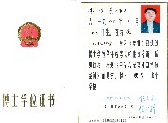
Passport/ Govt. ID Links/Upload/ Number (Age Proof) | 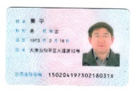
Personal website link | http://faculty.tju.edu.cn/QinXue/en/index.htm
Tick the Suitable award category | - Distinguished Scientist Award  - Young Scientist Award  - Life time achievement Award  - Outstanding scientist award  - Women Research Award  ▉Best Researcher Award  - Best Innovation Award | - Best Faculty Award  - Best Research Scholar Award  - Excellence in Innovation  - Excellence in Research  - Excellence Award (Any Scientific field)  - Best Research /Innovation Extension activity.
Self Declaration
I authenticate that to the best of my knowledge, the information given in this form is correct and complete. At any time I am found to have concealed any material information, my application shall be liable to be summarily terminated without notice. I have read the terms and conditions and other policies of the International Research Awards and agree to stand the same. I agree to Pencis to process the data submitted in this application form, or any other data that the Foundation may obtain from me for any purposes connected with Pencis for any other legitimate reason. The filled applications along with duly completed curriculum vitae, Pass port size photograph, Scan copy of the degree Certificate, Scan copy of the Working ID and related documents should be Upload in website/ sent via email to : contact@pencis.com
Date :2022/7/28 Place : Tianjin,PR.China Scanned Signature of Applicant

Office Use only

Decision | Reason | Signature of authorities | Date
Selected/Rejected

